

Membership Application Form

- Find us on Facebook or go to www.galwayastronomyclub.ie

Name ___________________________________________________

Address_________________________________________________

________________________________________________________

Telephone _________________ Mobile _______________________

Email___________________________________________________

Tell us more about yourself, What would you like to discover with Galway Astronomy Club?__________________________________
________________________________________________________

________________________________________________________

Do you own Binoculars (Y or N) ______________________

Do you own a Telescope (Y or N) _______________________

Would you like to attend Club Meetings/Workshops or Seminars?

________________________________________________________

Would you like to help us out ________________________________
(Does not affect your application in any way, although we are always looking for help)

If you prefer more time please post this to the secretary, Ronan Newman at 26 Knoxville Manor, Charlestown,Co Mayo

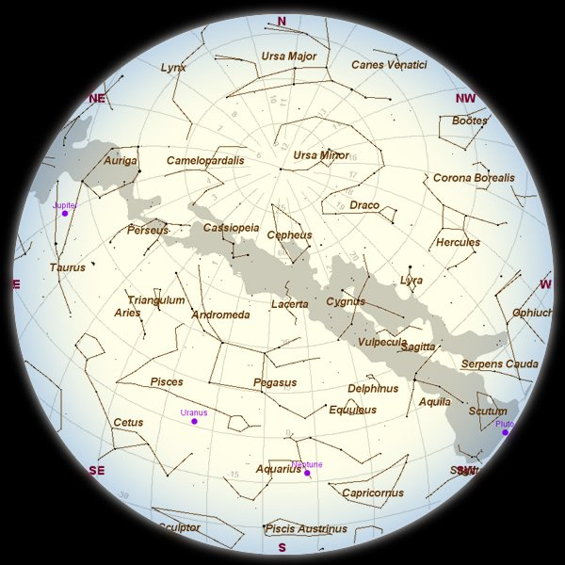

Moon-free October evenings are good times to watch the Milky Way -- the combined glow of millions of stars in the disk of the Milky Way galaxy as it arches from east to west. Several of the Milky Way's most famous constellations are immersed in its glow, so it's worth a look. Cygnus, the swan, is also known as the Northern Cross, because its brightest stars form the shape of a crucifix. See the beautiful double star; Alberio at the base of the cross. Cassiopeia, the Queen, stands atop the northern arch of the Milky Way. It looks like a letter M or W.
One of the brightest stars in the sky is yellow-orange Capella in the constellation Auriga, the charioteer. It's high in the northeast in mid-evening, and shines brightly amid the subtle glow of the Milky Way.
Altair in Aquilla is another bright star high in the South and in the Patrick Moore named Asterism “The Summer Triangle

OCTOBER 1ST

PUBLIC LECTURE: DR CRÉIDHE O'SULLIVAN

“NEW VIEWS OF THE EARLY UNIVERSE”

Westwood House Hotel 7.30pm


Find us on Facebook

or go to

www.galwayastronomyclub.ie

The most dramatic binocular object of the month is M31, the Andromeda Galaxy. Seen here late in the evening looking nearly straight up (zenith). It is a great spiral galaxy, similar to, our Milky Way galaxy but somewhat larger and lies about 2.5 million light years from us.
It can be seen with the naked eye as a faint elliptical glow and even better in Binoculars long as the sky is reasonably clear and dark.
The best way to using binoculars find it is to locate it is to find Cassiopeia and make a pointer down to the most eastern star in the constellation of Andromeda and hop west to the next star and then move slowly at to a 11pm position and you cant miss its elliptical shape.

